Special Shape RFID Tag Personalization Machine YPM-PPS-FOB
(PPS Washing Button Label Personalization Machine/Fob Key Tag Data Personalization Machine/Mini Card RFID Tag Personalization Machine YPM-PPS-FOB)

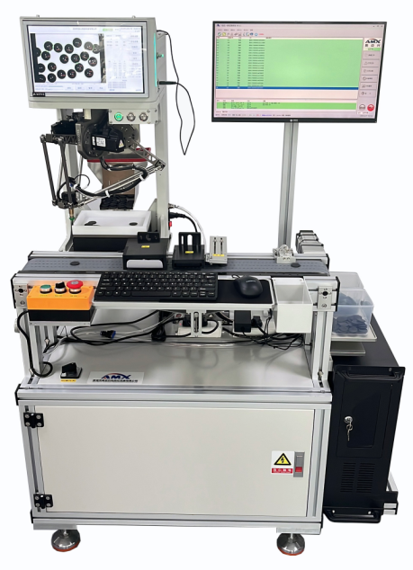
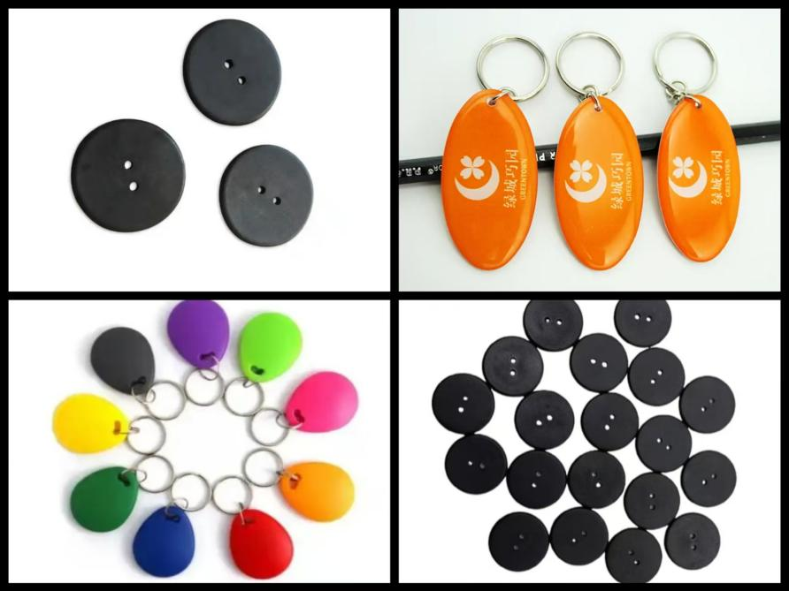

Special Shape RFID Tag Personalization Machine YPM-PPS-FOB is designed and made for the personalization process of various special shape RFID tags or cards including UHF PPS washing button label, Key Fob Tags and various mini cards. It can realize the functions of LF/HF/UHF chip data encoding, electronic performance testing and visual laser marking process in a speedy and precise way.
Special Shape RFID Tag Personalization Machine YPM-PPS-FOB applies the special visual material intelligent grasping module, which can realize automatic and smart robotic arm grasping and placing for special shape materials.
This machine also has the high-end visual laser marking module that can recognize the shape and pattern of materials, and then mark the precise data or logo on the chose area according to relevant settings of the equipment.
FYI, Special Shape RFID Tag Personalization Machine is also named or known as PPS Washing Button Label Personalization Machine, Fob Key Tag Data Personalization Machine, Mini Card RFID Tag Personalization Machine or All-in-one Electronic Label Personalization Machine.
Equipment Process Flow:
RFID tags or mini card feeding-HF+LF chip data personalization (read UID/write data/change key)-(optional) UHF chip data perso (read UID/write data/change key)-Visual laser marking process-NG rejection-Finished product counting and collection

Equipment parameters:

1. External dimensions: L1120mm*W800mm*H1500mm
2. Weight: 220 kg
3. Power Supply: AC 220V 50/60 Hz 1.5KW
4. Compressed air: ≤6.5 KG/CM²
5. Control Method: Industrial Computer + Visual Positioning System
6. Material specifications: UHF PPS washing button tags, Key FOB tags, non-standard small cards or mini cards.
7. Working speed: 2000-2500 pieces/hour;

Introduction to device functional modules:
1. Material storage and feeding module: equipped with material storage and feeding functions;
2. Visual material intelligent grasping module: Through visual material position recognition, the robotic arm automatically grasps and accurately places materials;
3. Material placement and conveying module: Material conveying vacuum adsorption accurately delivers materials to the testing station;
4. Chip data processing module: suitable for LF/HF/UHF chip UID reading, data writing, change key or testing.
5. Visual laser marking module: The visual system recognizes the shape and pattern of materials, and marks accurate data information according to the parameter requirements of the equipment;
6. NG material rejection module: Remove products without chips and with unsuccessful data reading and writing;
7. Material collection module: Materials are collected and automatically counted, and collected in boxes according to the set values;

